**Data Flow Diagrams:**

Project Design Phase-II

Data Flow Diagram & User Stories

|  |  |
| --- | --- |
| Date | 03 October 2022 |
| Team ID | PNT2022TMID27348 |
| Project Name | Plasma donor application |
| Maximum Marks | 4 Marks |

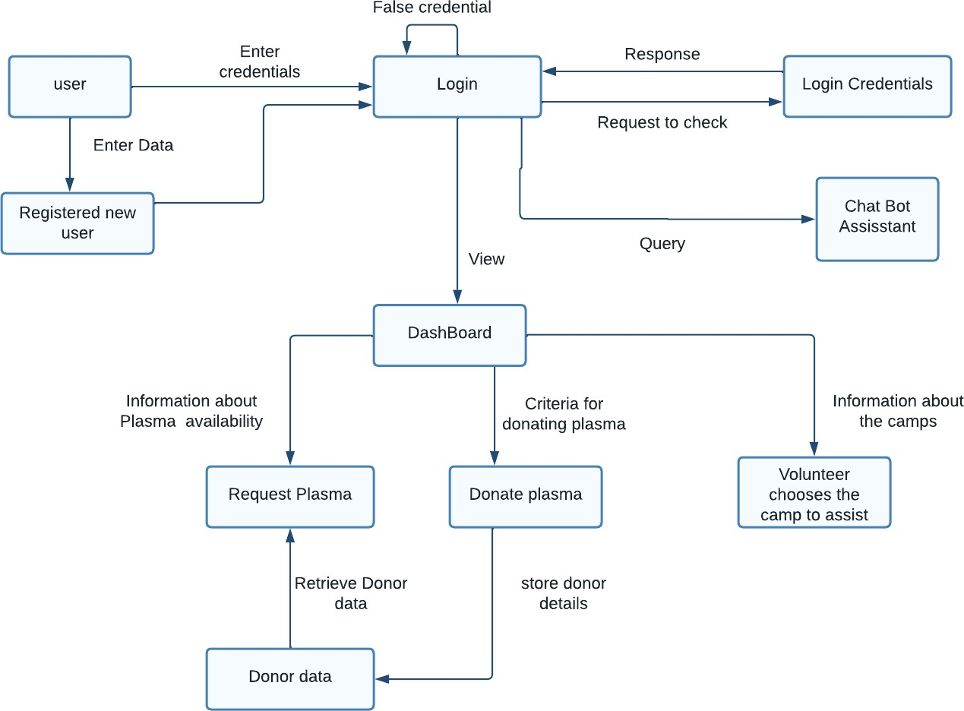

**User Stories**

Use the below template to list all the user stories for the product.

|  |  |  |  |  |  |  |
| --- | --- | --- | --- | --- | --- | --- |
| **User Type** | **Functional Requirement**  **(Epic)** | **User Story Number** | **User Story / Task** | **Acceptance criteria** | **Priority** | **Release** |
| Customer (Mobile user) | Registration | USN-1 | As a user, I can register for the application by entering my email, password, and confirming my password. | I can access my account / dashboard | High | Sprint-1 |
|  |  | USN-2 | As a user, I will receive confirmation email  once I have registered for the application | I can receive confirmation  email & click confirm | High | Sprint-1 |
|  |  | USN-3 | As a user, I can register for the application through Gmail | I can receive confirmation notifications through Gmail | Medium | Sprint-1 |
|  | Login | USN-4 | As a user, I can log into the application by  entering email & password | I can access into my User  profile and view details in dashboard | High | Sprint-1 |
|  | Dashboard | USN-5 | As a user,I can send the proper requests to  donate and obtain plasma. | I can receive appropriate  notifications through email | High | Sprint-1 |
| Customer (Web user) | Login | USN-6 | As a user,I can register and log into the application by entering email & password to  view the profile | I can access into my User profile and view details in  dashboard | High | Sprint-1 |
|  | Dashboard | USN-7 | As a user,I can send the proper requests to donate and obtain plasma. | I can receive appropriate notifications through email | High | Sprint-1 |
| Customer Care  Executive | Application | USN-8 | As a customer care executive,I can try to  address user’s concerns and questions | I can view and address  their concerns and questions | Medium | Sprint-2 |
| Administrator | Application | USN-9 | As an administrator I can help with user-facing  aspects of a website, like its appearance, navigation and use of media. | I can change the  appearance and navigation in a user friendly manner | Medium | Sprint-3 |
|  |  | USN-10 | As an administrator, I can involve working with  the technical side of websites. | I can help with such as  troubleshooting issues, setting up web hosts, ensuring users have access and programming servers | Medium | Sprint-1 |

|  |  |  |  |  |  |  |
| --- | --- | --- | --- | --- | --- | --- |
| **User Type** | **Functional Requirement**  **(Epic)** | **User Story Number** | **User Story / Task** | **Acceptance criteria** | **Priority** | **Release** |
| Chatbot | Dashboard | USN-11 | In addition the Customer care executive,chatbot can try to address user’s  concerns and questions | I can reply to all the queries related to our  application | Medium | Sprint-3 |